**NOAA Ship THOMAS JEFFERSON Procedure Document**

Procedure:

**Sound speed comparison cast**

Creation Date:

8/31/2020

Revision Date:

03/22/2022

Software used:

Sounds speed manager

Procedure Number:

**TBD**

Approved:

**TBD**

# Overview and Scope

How to conduct a Comparison Cast for HSRR

# Procedure Inputs and Outputs

## Inputs:

## Outputs:

# Procedure

Once you receive your CTDs and MVP sensors back from calibration, you need to conduct a comparison cast. To conduct a comparison, you need to shackle your CTDs to the MVP and conduct a static cast. You should not shackle more than 2 CTDs to the MVP at one time as the MVP winch cannot handle the weight. If need be, you can do more than 1 static cast and compare the casts form the CTD to the MVP sensor using the MPV as the baseline sensor.

It is easiest to conduct these casts using 3 personnel: 2 people on deck at the MVP and 1 person at the acquisition station to manually log the MVP cast and to monitor sensor depth. Follow the same procedure that is used for static CTD casts. Use the MVP winch to lower the sensors to just below the surface and allow them to soak for at least 2 minutes. At the end of the soak time, let the acq station know that you are going to begin lowering the sensors. The acq station will then start manual logging in the MVP controller program. The acq station will also monitor the sensor depth on the MVP display plot and will radio the deck personnel when to stop the cast (2m from the bottom). MVP personnel will then recover the towfish and CTDs. This process is repeated until all CTDs have logged a cast alongside the MVP.

Once your casts are complete, bring the casts into sound speed manager and process them as you normally would. You need to Export the data in order to enter the cast into the project database. The file and format that you export does not matter as we are only using the cast within the project database.

Once your casts are in the database within sound speed manager, Select your cast > “Right click” on cast > and select “Comparison plot”.

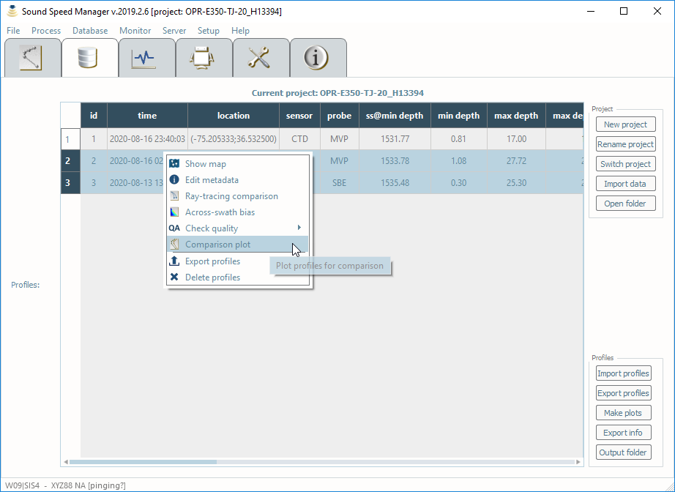

A dialog box will pop up. You need to plot sound speed, temperature, and salinity. You will have to repeat the steps above to plot each one individually.

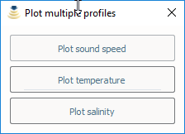

Adjust the legends to show which sensor is what line within the plot and save the plot. See example below.

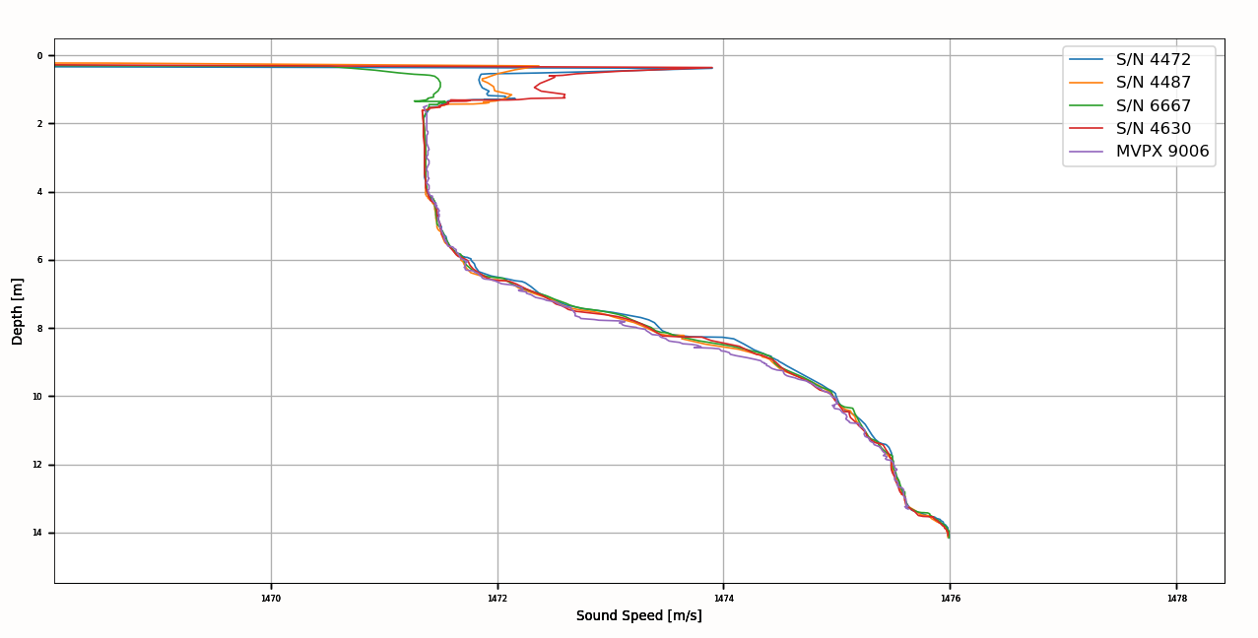

With each plot saved with the legends set, write up a short document describing how you conducted the cast comparison, what sensors you used, and what your findings were. You can refer to previous Cast comparison documents for HSRR for guidance on how to write up this document.

# References

N/A